

SUBJECT | English:  Reading and Viewing |  | DATE | July 2015
GRADE | 11 |  | MARKS | 90
EXAMINER | Mrs Leeburn,  Mrs Oosthuysen,  Mr De Reuck |  | MODERATORS | Mrs Nichas,  Mr De Reuck,  Mrs Oosthuysen
NAME |  |  | DURATION | 2 ½ hrs + 10 mins reading
CLASS
LOW ORDER | 60% | HIGH ORDER |  | 40%

INSTRUCTIONS
- This exam consists of x pages.
- Draw a right hand margin on each page you use.
- Start every new question at the top of a new page.
- Number in the middle of the page, according to the question paper.
- Leave a line between each answer.
- It is in your own interest to write legibly and to present your work neatly.

Question | 1 | 2 | 3 | 4 | 5 | Total
Possible Marks | 30 | 10 | 20 | 20 | 15 | 95
Actual Marks

COMMENT:

QUESTION 1 - comprehension 30 MARKS
Read TEXT 1 and answer the questions below.

1.1 Who are the fundamentalists who carried out the attack and who are the victims? (2)
1.2 What is the relevance of the timing of the attack? (2)
1.3. 1.3.1 Considering who Al-Shabaab is, do you think that having killed fellow Muslim people will stop their attacks? Justify your answer. (2)
1.3.2 How does the use of language in the title of the text further emphasise this? (2)
1.3.3 What is the writer challenging the western press to do? (Paragraph 2) (2)
1.4 The slogan for the University of Garissa is “Oasis of Innovation”. Explain the irony
of the slogan in relation to the attack. (2)

1.5 How has the attack united students? (2)

1.6 To what extent is the Kenyan tertiary education system successful in overcoming prejudice? (Paragraph 2) (3)

1.7 1.7.1 Why is Garissa not such a popular campus? (1)
1.7.2 In what way might this actually affect inter-denomination relations? (2)
1.8 Refer to paragraph 4.
1.8.1 What comment is being made by students about the Kenyan social elite? (3)

1.8.2Why did the British government advise its citizens not to visit Kenya? (1)

1.8.3 How has corruption allowed Al-Shabaab to infiltrate all aspects of Kenyan society?(3)

1.11 Identify and correct the grammatical error in the sentence: “There is concern that the recurrence of terrorist acts will achieve their aim of creating deep division among Muslim citizens and all the others.” (Par 5) Provide a reason for your answer. (3)

QUESTION 2: SUMMARY 10 MARKS
Read TEXT 2 and then answer the question which follows:

Summarise the text, focusing on the reasons for Africa’s expenditure on arms and the consequences of this expenditure.

- Use no more than 100 words.
- Provide a title for the summary (included in the word count)
- Use your own words. Lifting words from the text will be penalised.
- Provide a word count at the end of the summary.

QUESTION 3: POETRY 20 MARKS
Read Ulysses by Tennyson and Old Folks laugh by Angelou and answer the questions that follow.

3.1 SEEN POETRY
ULYSSES – Alfred Lord Tennyson
It little profits that an idle king,
By this still hearth, among these barren crags,
Match'd with an aged wife, I mete and dole
Unequal laws unto a savage race,
That hoard, and sleep, and feed, and know not me. 5
I cannot rest from travel: I will drink
Life to the lees: All times I have enjoy'd
Greatly, have suffer'd greatly, both with those
That loved me, and alone, on shore, and when
Thro' scudding drifts the rainy Hyades 10
Vext the dim sea: I am become a name;
For always roaming with a hungry heart
Much have I seen and known; cities of men
And manners, climates, councils, governments,
Myself not least, but honour'd of them all; 15
And drunk delight of battle with my peers,
Far on the ringing plains of windy Troy.
I am a part of all that I have met;
Yet all experience is an arch wherethro'
Gleams that untravell'd world whose margin fades 20
For ever and forever when I move.
How dull it is to pause, to make an end,
To rust unburnish'd, not to shine in use!
As tho' to breathe were life! Life piled on life
Were all too little, and of one to me 25
Little remains: but every hour is saved
From that eternal silence, something more,
A bringer of new things; and vile it were
For some three suns to store and hoard myself,
And this gray spirit yearning in desire 30
To follow knowledge like a sinking star,
Beyond the utmost bound of human thought.

This is my son, mine own Telemachus,
To whom I leave the sceptre and the isle,—
Well-loved of me, discerning to fulfil 35
This labour, by slow prudence to make mild
A rugged people, and thro' soft degrees
Subdue them to the useful and the good.
Most blameless is he, centred in the sphere
Of common duties, decent not to fail 40
In offices of tenderness, and pay
Meet adoration to my household gods,
When I am gone. He works his work, I mine.
There lies the port; the vessel puffs her sail:
There gloom the dark, broad seas. My mariners, 45
Souls that have toil'd, and wrought, and thought with me—
That ever with a frolic welcome took
The thunder and the sunshine, and opposed
Free hearts, free foreheads—you and I are old;
Old age hath yet his honour and his toil; 50
Death closes all: but something ere the end,
Some work of noble note, may yet be done,
Not unbecoming men that strove with Gods.
The lights begin to twinkle from the rocks:
The long day wanes: the slow moon climbs: the deep 55
Moans round with many voices. Come, my friends,
'T is not too late to seek a newer world.
Push off, and sitting well in order smite
The sounding furrows; for my purpose holds
To sail beyond the sunset, and the baths 60
Of all the western stars, until I die.
It may be that the gulfs will wash us down:
It may be we shall touch the Happy Isles,
And see the great Achilles, whom we knew.
Tho' much is taken, much abides; and tho' 65
We are not now that strength which in old days
Moved earth and heaven, that which we are, we are;
One equal temper of heroic hearts,
Made weak by time and fate, but strong in will
To strive, to seek, to find, and not to yield. 70

3.1.1 What is Ulysses’ attitude towards the people of Ithaca? Quote from the poem to support your answer. (3)

3.1.2 Explain the effectiveness of the metaphor in lines 19 -21. (2)

3.1.4 Why does Ulysses believe his son, Telemachus, will make a better king than him? (2)

3.1.5 What does Ulysses mean when he claims I am become a name (line 11)? (2)

3.1.6 Explain the allusion to the Happy Isles (line 63). (2)
3.1.7 Discuss how the tone of the final line captures the intention of the poet. (3)

3.2 UNSEEN POETRY

OLD FOLKS LAUGH – Maya Angelou

They have spent their
content of simpering,
holding their lips this
and that way, winding
the lines between 5
their brows. Old folks
allow their bellies to jiggle like slow
tambourines.
The hollers
rise up and spill 10
over any way they want.
When old folks laugh, they free the world.
They turn slowly, slyly knowing
the best and the worst
of remembering. 15
Saliva glistens in
the corners of their mouths,
their heads wobble
on brittle necks, but
their laps 20
are filled with memories.
When old folks laugh, they consider the promise
of dear painless death, and generously
forgive life for happening
to them 25

3.2.1 Discuss whether this poem reflects or refutes Ulysses’ attitude towards old age.
Make close reference to both poems and examine aspects of imagery and diction in your answer. (4)
3.2.2 Describe the attitude of the poet (Maya Angelou) towards the old people to whom she refers in this poem. Quote to support your answer. (2)

QUESTION 4: visual literacy 20 MARKS
The cartoon below is a scene from South African history, showing the first European colonizers arriving at the Cape. The Cape was already inhabited by the indigenous Khoi and two Khoi are observing Jan Van Riebeeck and his men arriving.

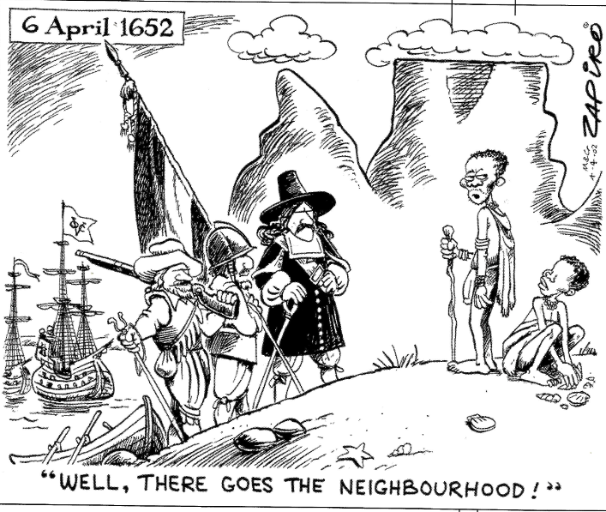

4.1 What are the visual and verbal clues that enable you to recognise the time and place? (3)

4.2 How do you think the reader’s attitude towards colonialism may influence his/her response to the cartoon? (2)

4.4 Do you believe that the Khoi are intimidated by the arrival of the new-comers? Explain your answer with close reference to the visual details. (3)

4.5 In terms of the composition, the standing Khoi occupies a higher position than all of the Europeans. What effect does this have on the reader’s interpretation of the situation? Repeat of 4.4 (1)

4.6.1 Explain the idiomatic expression, “Well, there goes the neighbourhood.” (1)
4.6.2 Which group of people is saying these words? Explain your answer. (2)

4.7 Explain how these words reveal the cartoonist’s own position on colonialism. (2)

South Africa is an ex-colony and has recently emerged from Apartheid rule where white people owned most of the land. Issues of land ownership and redistribution remain unresolved.
4.8 This cartoon is not only about the past. Who would benefit in South Africa today from leaving land issues in the past and who would not? (2)

Sometimes a political cartoonist appropriates or ‘borrows’ an image that already exists in the public domain and alters it for the purpose of criticizing the original event or issue. Study the painting below by Charles Bell that Zapiro ‘borrowed’ and answer the question that follows.
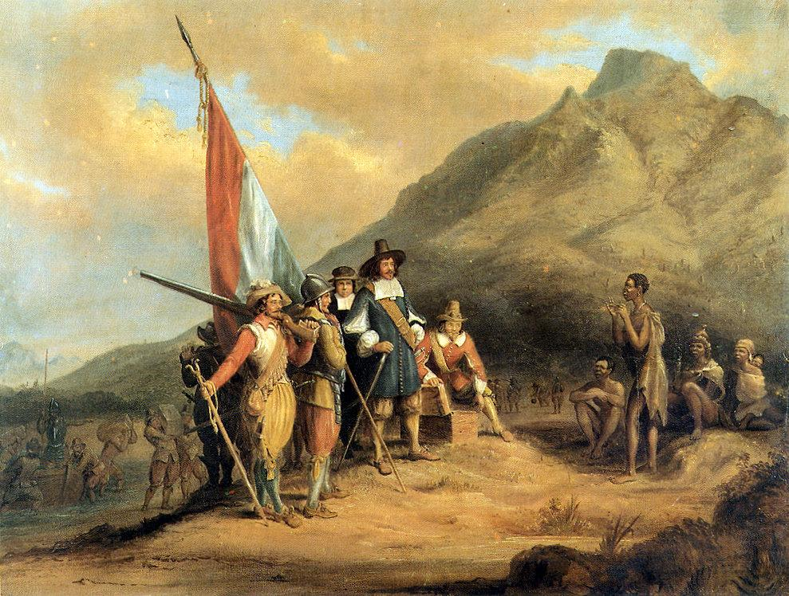

4.9 Identify two differences between Zapiro’s cartoon and this painting and explain what it is about each of these changes that creates a new and critical meaning. (4)

QUESTION 5: TEXTUAL EDITING 15 MARKS

Read TEXT 3 to answer the questions below:
`
5.1 Explain the effectiveness of the title. (2)

5.2 Identify the hyperbole in sentence 2 and explain its effect . (2)

5.3 5.3.1 Stylistically, how can sentence 2 be edited to improve the flow of the sentence? Provide a reason for your answer. (2)

5.4
5.3 Account for the use of capital letters in reference to ‘Buddha, The Enlightened’ (paragraph 4) (1)
5.4 How does the use of diction position us, as readers, to view this incident? (2)
5.5 Why would ‘UNESCO’ be referred to as an acronym and not just an abbreviation? (1)

5.6 Refer to the last sentence of this text: “Had the appropriate measures been taken in time, the calamity would not have been so horrendous.”

5.6.1 Identify the main and sub-ordinate clauses. (2)
5.6.2 What is the effect of the sentence being a periodic sentence?
Your answer should consider who is being held responsible for the outcome
of the disaster. Be specific and justify your answer. (3)

